DeRidder Thursday Study Club Supports Efforts to Fight Erdheim-Chester Disease
By Elizabeth S. Anderson
January 7, 2017

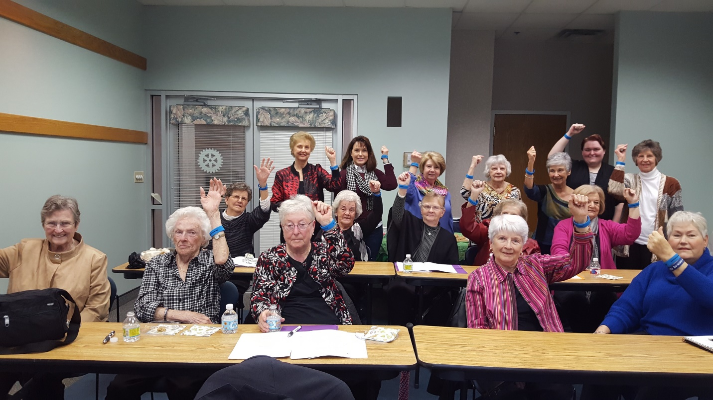
The women of the DeRidder Thursday Study Club show-off their Erdheim-Chester Disease awareness wrist bands to support those affected by ECD.

DeRidder, LA – This past Thursday, January 5th, ECD Global Alliance president and founder, Kathy Brewer, spoke to the DeRidder Thursday Study Club about the progress of local non-profit, the ECD Global Alliance. The study club’s members have supported the charity since its beginning. Many of the group’s women knew the founder’s husband, Gary Brewer, who passed of ECD in 2007. Group members have donated and volunteered to the ECDGA, supporting those affected by Erdheim-Chester disease.

The presentation covered how the ECDGA has helped patients and their families through a multi-lingual website, an annual medical symposium and patient gathering, and funded research to help find better treatments.

Plans for 2017 were also discussed. In April, physicians from the National Institutes of Health’s rare disease program will provide a talk to medical students and professionals at Louisiana State University and Tulane.

Erdheim-Chester disease (ECD) is a rare blood cancer. The illness is debilitating and can be life-threatening. To learn more or donate visit www.erdheim-chester.org.

