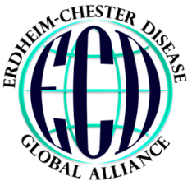
2019 International ECD Medical Symposium
Abstract Submission Form

Thank you for your interest in presenting your Erdheim-Chester Disease research and findings at the 7th Annual International ECD Medical Symposium in Milan, Italy on July 11, 2019 at the IRCCS San Raffaele Scientific Institute Vita-Salute San Raffaele University. The ECDGA is accepting abstracts from February 1 to April 1, 2019. Late breaking abstracts for poster presentations will be considered through May 1, 2019. The call for abstracts has expanded this year to include the latest advancements related to all histiocytoses, with a concentration on Erdheim-Chester disease.
The following form helps collect the necessary information to be included for the event program. Please submit this abstract form for a poster or oral presentation to Jessica Corkran at jessica.corkran@erdheim-chester.org by April 1, 2019. You will be notified about abstract acceptance, the session time, and the length of your session by May 13.

Title of Presentation:
Do you authorize the ECDGA to publish your presentation slides and video on the Erdheim-Chester.org webpage following this meeting?  Yes  No
Presentation Preference:  Poster  Oral
Please choose one of the following categories that best represents your presentation:
 Basic Science  Pathology  Treatments  Organ Involvement
 Other
Speaker:
Institution(s), City and Country:
Author(s):
Abstract Summary (500 words or less):

