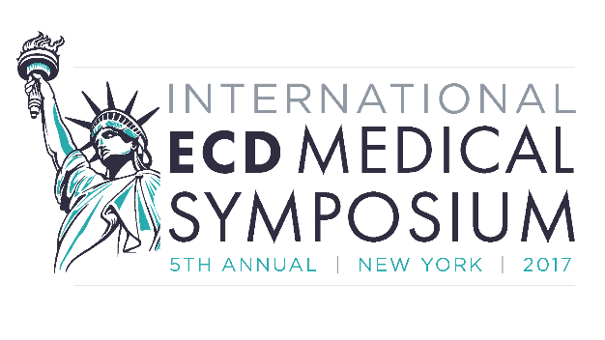
Thank you for your interest in presenting your Erdheim-Chester disease research and findings at the 5th Annual International ECD Medical Symposium in New York, NY on October 26, 2017 at the Marriott East Side hotel. The following form helps to collect the necessary information to be included in the event program. You will be notified about abstract acceptance, the session time, and the length of your session by September 1.
Please submit this abstract form for a poster or oral presentation to Jessica Corkran at jessica.corkran@erdheim-chester.org by August 1, 2017.
Title of Presentation:
Presentation Preference: Poster Oral
Please circle one of the following categories that best represents your presentation:
Basic Science Pathology Treatments Organ Involvement
Other_____________________
Author(s):
Institution(s), City and Country:
Speaker:
Abstract Summary (500 words or less):

