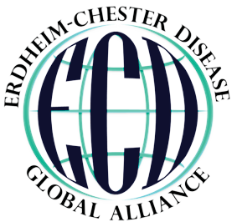

NAME OF LETTER RECIPIENT OR COMPANY

Sample Address 1234 Sample Drive.
Sample, SM 79089

ECD GLOBAL ALLIANCE A NONPROFIT 501 (C)(3) ORG.

BOARD OF DIRECTORS:
Linda Adams, PhD
Kathy Brewer
President
Jean Campbell
Juvianee Estrada-Veras, MD
NIH Federal Liaison
Pam Fleming
Rachel Mitchell
Treasurer
Glenn Padnick
STAFF:
Elizabeth Anderson
Jessica Corkran

SUPPORTING THOSE
AFFECTED BY ERDHEIM-CHESTER
DISEASE

ERDHEIM-CHESTER DISEASE GLOBAL ALLIANCE
ECD Global Alliance
P.O. Box 775
DeRidder, LA 70634 USA 337.515.6987
www.erdheim-chester.org

[Date]

Dear [name],

As you know, I [my husband/wife/daughter/son/etc.] has been diagnosed with Erdheim-Chester Disease, a rare condition in which healthy cells multiply unaccountably, leading to pain, blindness, organ failure, or even death. The disease has been recently classified as a as a histiocytic and dendritic cell neoplasm, or rare blood cancer.

I have found a non-profit group, the ECD Global Alliance, which supports patients and their families, fights to raise awareness of the disease (especially in the medical community) and funds ECD research. The organization has had a major impact in spite of its small budget.

The ECD Global Alliance has helped me [my husband/wife/daughter/son/etc.] by [offer a personal testimony on how you or your loved one benefits from the organization].

In 2017, the ECD Global Alliance will continue to increase the reach of the ECD Care Center Network that identifies institutions where experienced medical teams can treat patients with the newest and most effective treatments. It will fund Memorial Sloan Kettering Cancer Center to implement an ECD patient registry so that patients and doctors can analyze which treatments work best under which circumstances. Physician awareness projects are being planned to help patients to be diagnosed and begin treatment sooner. The 5th Annual Medical Symposium and Patient and Family Gathering events will also be hosted to bring the ECD community together for support and sharing of the most current research findings. All of this work translates into a better future together.

Please consider including the ECD Global Alliance in your holiday giving. You will be making a direct impact on an organization and a cause that means a lot to me.

Sincerely,

[your name]

SAMPLE NAME SAMPLE TITLE
email@email.com

